Create Custom ABAP Operator

1. Create one class with interface IF_LTAPE_GRAPH_OPERATOR. 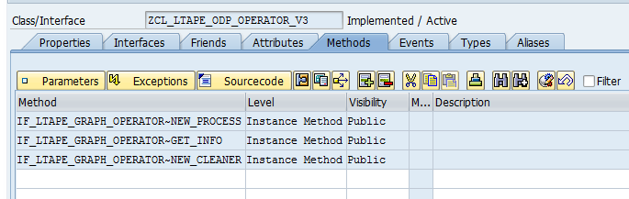
2. Open transaction LTAPE, click on “Generate BADI Implementation”. 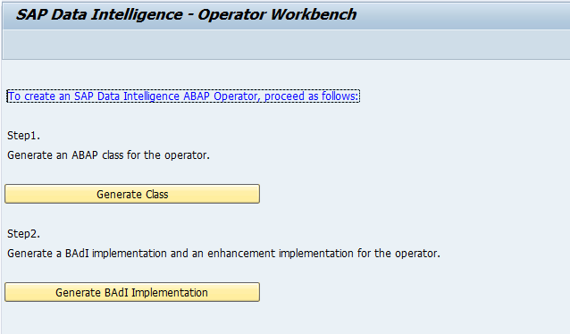
3. Provide details, 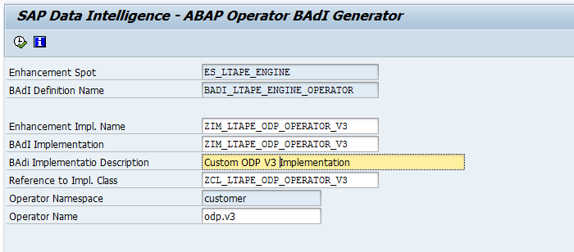
4. Operator gets created and it opens SE18 screen for BADI Implementation details. 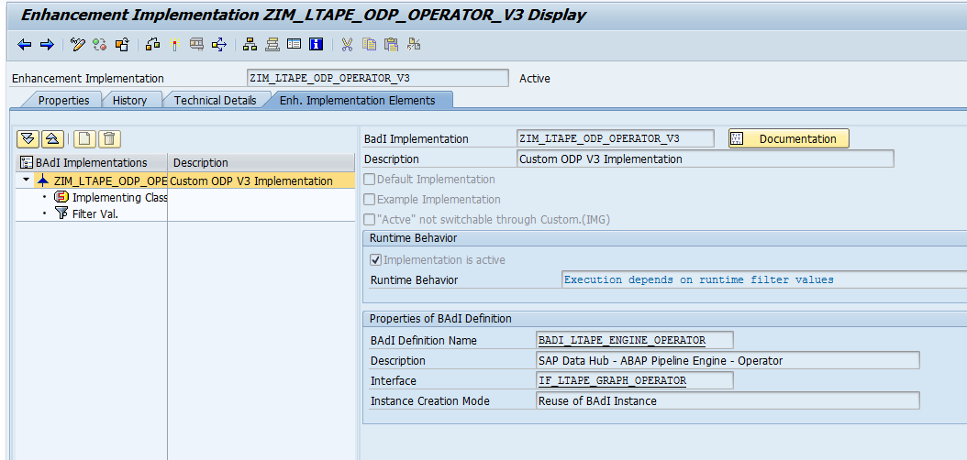
5. Filter is assigned with the operator’s name. 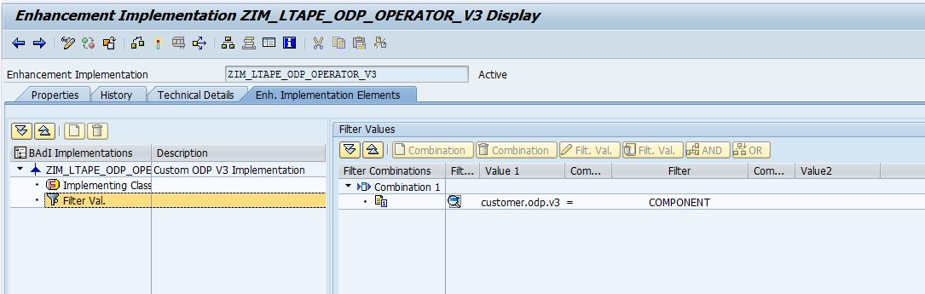
6. NEW_PROCESS is the method where it takes another one instance of ABAP class that implements interface IF_LTAPE_GRAPH_PROCESS, and this instance is responsible for graph execution. 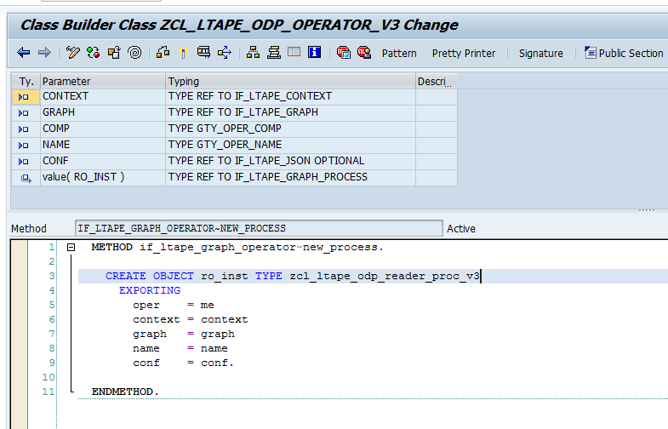
7. These are the interface methods which get invoked during execution of the graph. 